**Designing a PID controller for a rotational 2 DOF system**

**MAE 171A**

Sophia Davila, Agasthya Valluri, Parth Jha, Rohan Shah

## Results

While our primary objective was to create a PID controller for the rotational 2 DOF system, our subgoals included finding and validating the mass (${m)}_{}$, damping (${d)}_{}$, and spring (${k)}_{}$ constants of both disks. For this we conducted three sets of experiments, with MATLAB as the primary means of communicating with the system.

**Experiment 1 - To find $m_{1}$, $d_{1}$, and $k_{2}$ (constants of lower disk 1)**

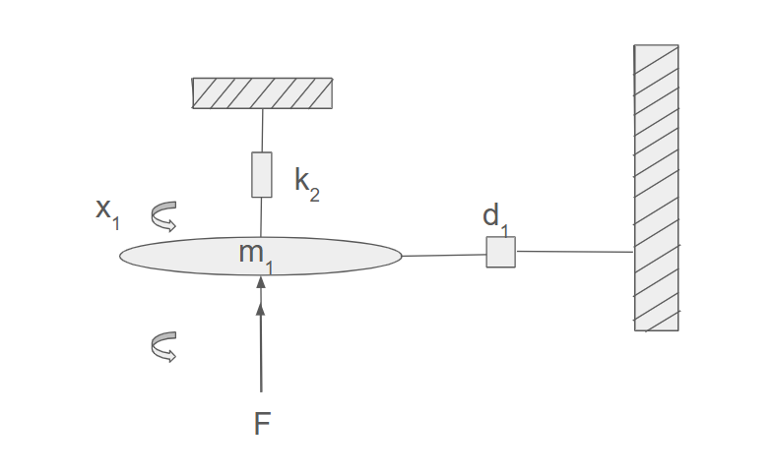

Fig 1. Schematic diagram of the 1 DOF system of disk 1

This experiment involved simplifying the rotational system by restricting it to one degree of freedom. We achieved this simplification by holding the top plate ($m_{2}$) in a fixed position while still allowing the bottom plate ($m_{1}$) to move. Our goal was to analyze the step response of this system, in order to solve for the constants. However, our controller only allowed for a square wave input to the driving motor. To overcome this, we decreased the frequency of the square wave to mimic a step input and applied a $0.5 V$ square wave with a frequency of 0.1 Hz for 1 repetition. This translated to a step input of $0.5 V$, and the system's response was recorded as the angular position of the bottom plate over time. The resulting graph displayed a response with an initial peak $y_{o}$ at time $t_{o}$, followed by subsequent peaks $y_{n}$ at $t_{n}$, where $t_{n}$ ​ represents the time of the n-th peak (e.g., $n=1$ corresponds to the second peak, $n=2$ to the third peak, and so on), and $y_{∞}$ at the settling time $t_{∞}$, which we chose to be the time when the height of 2 peaks have a difference of less than $10^{-3}$ encoder counts.

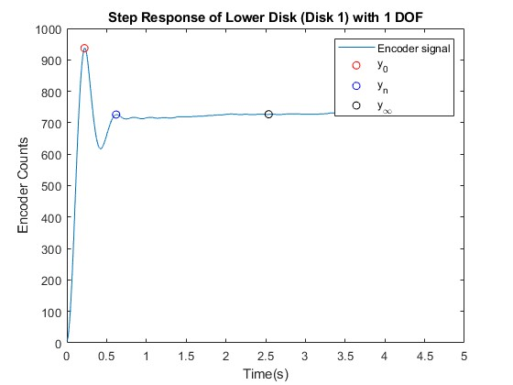

These $y_{}$ and $t$ values were used to calculate the key system parameters: mass ($m_{1}$), spring constant ($k_{2}$), and damping coefficient ($d_{1}$). We conducted the same experiment a total of 5 times, obtaining the values of $m_{1}$, $k_{2}$ and $d_{1}$ for all 5 trials. The 5 different results were used to calculate the average of the system's parameters, obtaining our final values for $m_{1}$, $k_{2}$ and $d_{1}$. Below are the formulas used to obtain the parameters.

${\hat{ω}}_{d}=2π\frac{n}{t_{n}-t_{o}}$

$β{\hat{ω}}_{n}=\frac{1}{t_{n}-t_{o}}ln(\frac{y_{o}-y_{∞}}{y_{n}-y_{∞}})$

${\hat{ω}}_{n}=\sqrt{{\hat{ω}}_{d}^{2}-{(β{\hat{ω}}_{n})}^{2}}$

$\hat{β}=\frac{β{\hat{ω}}_{n}}{{\hat{ω}}_{n}}$

$\hat{k}=\frac{U}{y_{∞}}$

$\hat{m} = \hat{k}\frac{1}{{\hat{ω}}_{n}}$

$\hat{d} = \hat{k}\frac{2\hat{β}}{{\hat{ω}}_{n}}$

Using those formulae, we obtained the following results for each of the 5 trials:

Trial I: $m_{1}^{I}=1.6×10^{-6}$, $d_{1}^{I}=4.3×10^{-5}$ and $k_{2}^{I}=6.88×10^{-4}$

Trial II: $m_{1}^{II}=2.53×10^{-6}$, $d_{1}^{II}=2.92×10^{-5}$ and $k_{2}^{II}=7.47×10^{-4}$

Trial III: $m_{1}^{III}=2.97×10^{-6}$, $d_{1}^{III}=2.82×10^{-5}$ and $k_{2}^{III}=9.73×10^{-4}$

Trial IV: $m_{1}^{IV}=3.69×10^{-6}$, $d_{1}^{IV}=3.75×10^{-5}$ and $k_{2}^{IV}=8.83×10^{-4}$

Trial V: $m_{1}^{V}=2.69×10^{-6}$, $d_{1}^{V}=2.7×10^{-5}$ and $k_{2}^{V}=8.53×10^{-4}$

To prevent bias, we took the average of the results for each trial and found the parameters to have the following values:

$m_{1}^{}=2.696×10^{-6}$, $d_{1}^{}=3.298×10^{-5}$ and $k_{2}^{}=8.288×10^{-4}$

**Experiment 2 - To find $m_{2}$ and $d_{2}$ (constants of upper disk 2)**

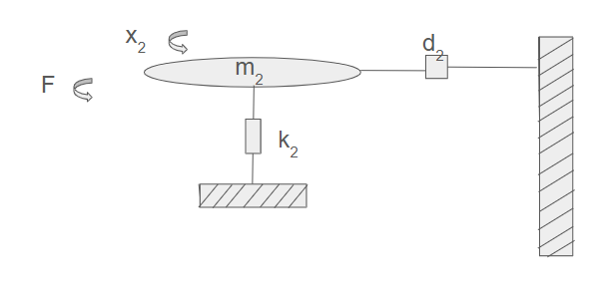

Fig 2. Schematic diagram of 1 DOF system of disk 2

In the second experiment, we again simplified the system to one degree of freedom. Since the driving motor was attached only to the bottom plate, we couldn’t analyze the step response of $m_{2}$**.** To overcome this, we fixed the bottom plate and applied a manual impulse to the top plate, and analyzed the impulse response of disk 2. We obtained a resulting graph that displayed an impulse response with an initial peak at $t_{o}$ and peaks at $t_{n}$. However, our experiment did not go on for long enough for us to observe the settling time ($t_{∞}$). That came out not to be a problem, since we only need $t_{∞}$ to calculate the spring constant $k_{2}$, which is the same for both plates and was already found in our first experiment. Additionally, even though we cannot see the settling time on the graph, we know that it would be near 0, since our input was an impulse instead of a step.

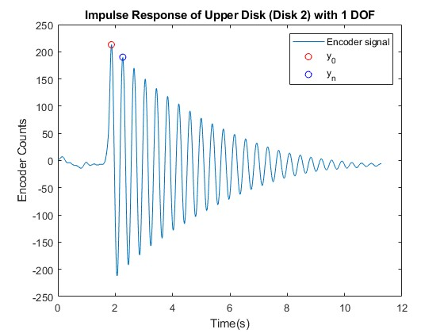

Similar to the first experiment, we repeated the process 5 times and used the values of $y_{o}$, $t_{o}$, $y_{n}$ and $t_{n}$ to calculate the parameters for the second plate ( $m_{2}$ and $d_{2}$). The results of the calculations for each trial are shown below:

Trial I: $m_{2}^{I}=3.1×10^{-6}$, $d_{2}^{I}=2.9×10^{-6}$

Trial II: $m_{2}^{II}=3.5×10^{-6}$, $d_{2}^{I}=3.1×10^{-6}$

Trial III: $m_{2}^{II}=3.2×10^{-6}$, $d_{2}^{I}=3.0×10^{-6}$

Trial III: $m_{2}^{II}=4.0×10^{-6}$, $d_{2}^{I}=3.2×10^{-6}$

Trial III: $m_{2}^{II}=2.8×10^{-6}$, $d_{2}^{I}=2.9×10^{-6}$

After taking the average, we found the disk 2 parameters to be:

$m_{2}^{}=3.3×10^{-6}$, $d_{2}^{}=3.05×10^{-6}$

**Experiment 3 - Validation of Parameters**

To validate our parameters for disk 1, we used the MATLAB script maelab2.m to simulate the step response for the top disk. We conducted the simulation using a voltage of 0.5 volts and a dwell time of 5 seconds. Then, we overlaid the simulated response with the 5 experimental step responses we took, and compared them. As observed in the graph of the validation, the simulated response closely matches with the measured responses, which confirms the accuracy of our estimated parameters.

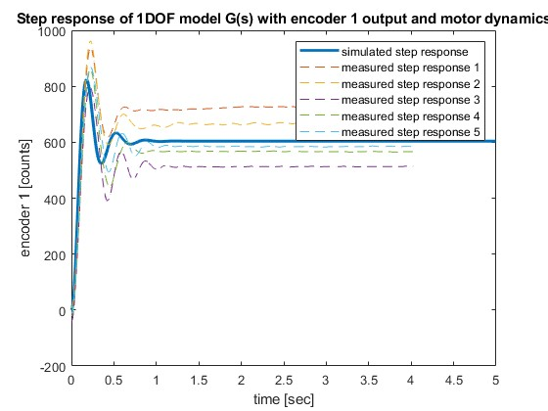

To validate the results for the second experiment, we simulated an impulse response. Since the impulse was applied manually by hand and was not precisely controlled, we approximated the scaling factor to 0.012 based on the simulated response. This factor was estimated because it was impossible to ensure consistent input magnitude among the trials, though we know it was a small impulse. The exact magnitude of the impulse did not factor much into the validation because it was the decay of the peaks that we aimed to match with the simulation. The simulated impulse response was overlaid with the experimental responses, and again, the results showed a good match between the simulated and the measured data, which again helps us confirm the accuracy of the estimated parameters for the top plate.

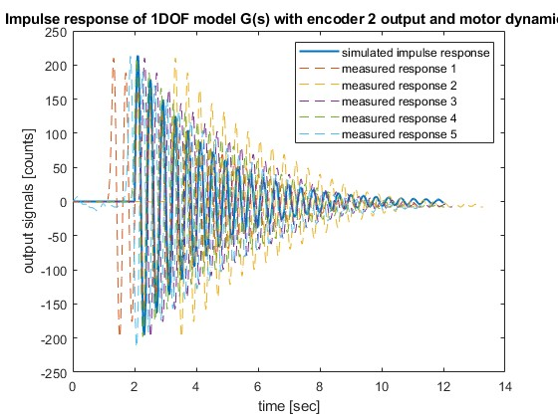

Additionally, we also conducted a validation test with the step response of the entire 2 DOF system. However, we approached the measurement of this data with caution because of the unrestricted nature of the 2 DOF system which could have caused the system to spin uncontrollably. To prevent this, we would turn off the system within 3-5 seconds of the motor turning on and simulate using maelab2 accordingly. This wasn’t our primary validation test because of the randomness in the dwell time of switching the motor off. This validation plot is shown below:

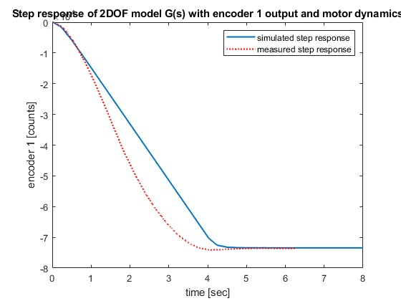

From these three sets of experiments, we were able to measure and validate the unknown parameters of the two disks and gave us the transfer function we needed to design a feedback loop.

In our next set of experiments, we sought to design a PID controller to ensure that the Disk 1 (Lower Disk) gets to the prescribed location of 1000 encoder counts with an overshoot less than 25% within the fastest settling time possible.

We started with designing a P controller to calculate ${{k_{p}}^{max}}_{}$, which we defined to be the value of $k_{p}$ where the system becomes unstable. This was done through an iterative process of using the section of *maelab2.m*  script that calculated the stability of the closed loop system. After a series of trials, we found ${k_{p}}^{max}$ to be 0.53. Going ahead, we tuned a PID controller such that

$k_{p}≤\frac{{k_{p}}^{max}}{2}$

We did this to ensure our $k_{p}$ didn’t cause our system to spin out of control with a factor of safety of two. After ensuring the stability of the system, we experimented with the physical system and found that a $k_{p}$ the value of 0.264 gave us the fastest rise time. Using this as our initial $k_{p}$ value, we used MATLAB’s Control System Designer application to tune our derivative and integral constants.

I found the tau and I put one pole at the origin and one pole at -1/tau and then played around with the zeroes until I found something that worked.

1DOF motion equation

$m_{1}ẍ_{1}+d_{1}ẋ_{1}+k_{2}x_{1}=F(t)$

$G=\frac{3.223 ⋅ e^{-8}⋅ s^{2} + 2.979 ⋅ e^{-8}⋅ s + 8.086 ⋅ e^{-6}}{3.6 ⋅ e^{-14}⋅ s^{5} + 7.974 ⋅ e^{-12}⋅ s^{4} + 1.166 ⋅ e^{-10}⋅ s^{3} + 4.817 ⋅ e^{-9}⋅{ s}^{2}+2.438 ⋅ e^{-8}⋅ s}$

Abstract

Introduction

What the system is (diagrams, whats the reason, why are we doing this)

Why we used step response, what we expect as response of the system given an input, 2DOF system and 1DOF system that we modeled (explain), explain code (parameters in terms of variables) fbds, equations) k, m and damping ratio, mention controllers (PID PD controllers)

Results

Mat lab plots of response looks like to step, what we expect the output to be.

Experiments -

First experiment - held top plate (disk 2) gave it a step function and saw system response

Second experiment - held bottom plate (disk 1), gave an impulse and saw what the response was

Simulations - 2DOF system using matlab and compared the experimental results (parameters) with the theoretical parameters

Discussion

Discuss the comparison plot (simulated and measured response)

Missing design of the controllers - do next

c

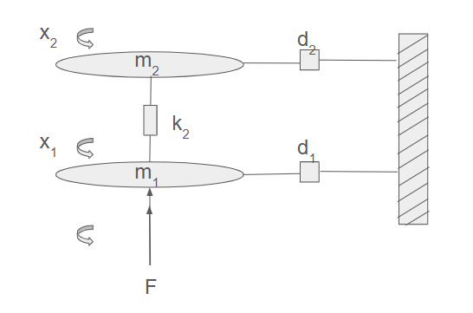

$m_{1}ẍ_{1}+d_{1}ẋ_{1}+k_{2}{(x}_{1}-x_{2})=F(t)$

Using the parameters obtained from Experiments 1 and 2, we simulated a two-degree-of-freedom (2 DOF) system, as depicted in Figure (). The simulation was based on the governing equation (), and the system's response was compared to a square wave input.

To measure the system’s response to a step response input, we applied a square wave input to the system, and turned the system off to simulate a unit step input.

We notice a pretty close agreement between the simulated response and the measured response to a unit step response. The disagreement between the measured response and the simulated response

Our results indicate that the 2 DOF system exhibited an underdamped behavior, which aligns with theoretical expectations.

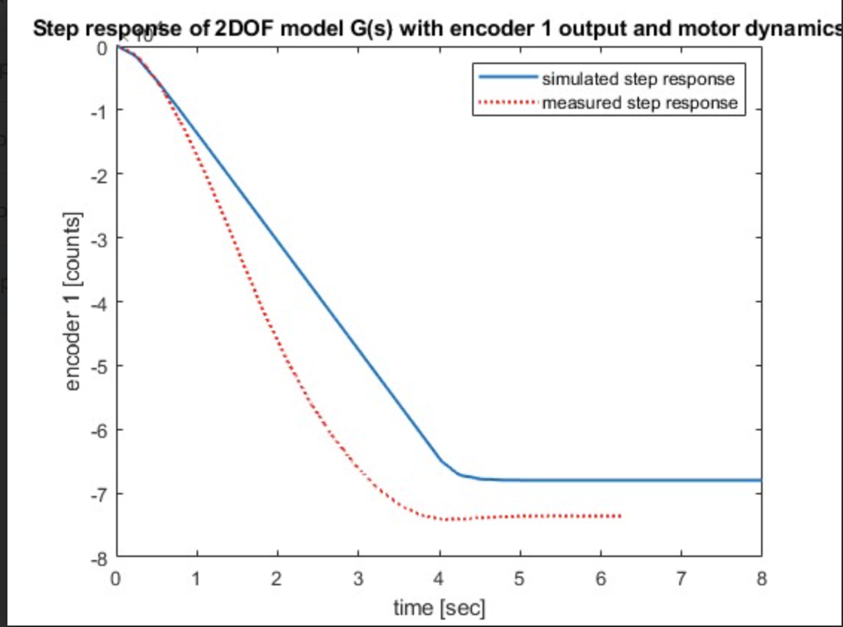

$m_{1}$, $k_{1}$, $d_{1}$ and $m_{2}$, $k_{2}$, $d_{2}$

we simulated a 2 DOF system as shown in figure () using the equation () and compared the output to a square wave.

2nd Newton’s law ∑ F = ma to describe dynamic behavior:

$m_{1}ẍ_{1}=-k_{1}x_{1}-d_{1}ẋ_{1}-k_{2}{(x}_{1}-x_{2})+F$

$m_{2}ẍ_{2}=-k_{2}(x_{1}-x_{2})-d_{2}ẋ_{2}$

$m_{1}ẍ_{1}+d_{1}ẋ_{1}+{(k}_{1}+k_{2})-k_{2}x_{2}=F$

$m_{2}ẍ_{2}+d_{2}ẋ_{2}+k_{2}x_{2}-k_{2}x_{1}=0$

$ω_{n}=\sqrt{{ω^{2}}_{d}+}$

ω n =

√

ˆω 2

d + ( ˆβω n ) 2

𝐼! ̈ θ! = 𝑇 + k " 𝜃" − 𝜃! − 𝑑! ̇ 𝜃!

𝐼" ̈ θ " =

Hardware in the Lab – mechanical systems

rectilinear system (left) and torsional plant (right)

• input u = voltage V to serv

Abstract:

This experiment focuses on the study of torsional position control systems and analysis of open-loop and closed-loop control systems. Through the open loop experiments, we aim to understand the dynamic behavior of the system by applying unit step and impulse response inputs and analysing the encoder outputs. On the other hand, the closed loop experiments involved the design and validation of feedback control algorithms, including proportional (P), proportional-derivative (PD), and proportional-integral-derivative (PID) controllers. By comparing simulation models with experimental results to ensure the stability and performance of the control algorithms. Through MATLAB we acquired data, validated results and designed controllers. These experiments provide insights into the dynamics of control systems and effectiveness of control algorithms in achieving required performance while maintaining stability.

MATLAB is utilized extensively for trajectory design, data acquisition, and validation of models and control strategies. The findings of this experiment provide insights into the dynamics of controlled systems and the effectiveness of various control algorithms in achieving desired performance while maintaining system stability and safety.

Through closed loop experiments

The experiment consists of a motor-driven mechanical setup

with position feedback, enabling the implementation of trajectory-based control strategies.

ings of this experiment provide insights into the dynamics of controlled systems and the effectiveness of various control algorithms in achieving desired performance while maintaining system stability and safety.

Discussion: